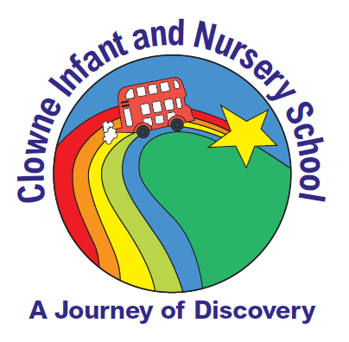

Clowne Infant and Nursery School,
Ringer Lane,
Clowne,
Chesterfield,
S43 4DB.

Headteacher: Mrs S. Kirby
Dep Headteacher: Mrs C Galley
Tel: 01246 810518

17th March 2020

Dear Parents and Carers,
As you’re probably aware, the government’s guidance on the Coronavirus has changed from the ‘contain’ phase to one of ‘delaying’ the spread of the virus and this may continue to change again at any time. We’re getting in touch to let you know what we’re doing in light of this, and what we expect from all of you, to help make sure our school community keeps safe and calm.
We’d like to reassure you that at Clowne Infant & Nursery School we’re taking all of the necessary steps to protect our community and are continuing to follow official guidance from the Government and Public Health England.
What’s the current situation?
- The school remains open – this is the current official guidance we’ve been given so far
- Breakfast club will continue to run as normal.
- If you, your child or anyone you live with has the following symptoms you must follow guidance to stay at home:
- A new, continuous cough and/or
- A high temperature
- If your child is unwell or is self-isolating, report this as you would normally by calling the school office on 01246 810518.
In line with government daily briefings, we will keep you up to date with any pertinent changes to the current situation.
What we’re doing to protect and support pupils and staff
- All our children have had several assemblies and reminders, detailing how to effectively wash their hands. These are enforced and monitored throughout the day.
- We are displaying posters illustrating the importance of hand washing.
- Additional soap and tissues are available in all classrooms and public areas.
- The number of visitors in school has been reduced and only essential, safeguarding meetings are going ahead.
- Our cleaning team are currently cleaning and disinfecting regularly touched surfaces and objects.
- If children feel ill whilst at school, we will follow the Public Health England guidance and will call you immediately should we be concerned.
What could you do to help us?
- If you’ve recently changed your contact details, please inform the school office as soon as possible via 01246 810518

- Talk to your children about the coronavirus. It’s a scary time and we should make sure children feel supported. BBC Newsround has regular updates for younger children.
- Please collect your child straight away, if we call you (we’ll contact you if they become ill with either a temperature or a new, continuous cough)

What happens if our school has to close?
We’ll only close if we’re either officially advised to do so or we don’t have enough staff to operate safely.
In either case, we will:
- Text all parents and publish on our website indicating closure.
- Text all parents and publish on our website details of when we expect to reopen.
- We have created a list of things for children to do at home and will send this with an excercise book. Please keep in mind that we’re only sending out this information to help the school community prepare. There are currently no plans to close.

If you have any questions
Please consult the:
- School office, if you have any questions about our response to this issue.
- NHS, if you want to know more about the symptoms of coronavirus. If you think you or your child may have the symptoms, use NHS 111 online if at all possible before calling 111.
- Department for Education’s Coronavirus helpline: 0800 046 8687, if you have any questions about the government’s response to coronavirus in relation to schools.
- Government’s travel advice, if you want to know whether any upcoming trip or holiday you’re taking abroad should go ahead.
It’s a tricky time and we know you’re worried about the impact this might have on our community. It’s important we keep each other safe and talk about these events to help with any anxiety.
Please contact us should you need additional advice and guidance. Thank you for your continued support.

This information is accurate at 2pm on 17th March 2020

Yours sincerely,
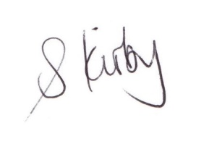
Susie Kirby
Headteacher

