

**Clowne Infant and Nursery School**



**Attendance really matters!**

**Every pupil, all day, every day**

**School success starts with attendance….**

**School Attendance is a legal requirement!**

**“Section 444(1) Education Act 1996** – If the child is absent without authorisation then the parent is guilty of an offence. This is a strict liability offence i.e. all that needs to be shown is a lack of regular attendance. Sanctions can include a fine of up to £1,000.

We had some brilliant feedback at our recent Ofsted review, but an area of **serious** concern is our attendance. Extremely frustratingly, our overall attendance this year is in the bottom 20% of all schools in the country…….

All forms of absence, including holidays as well as illness, determine our overall attendance. The below charts shows the serious impact that persistent absence, and just one holiday can have during term time.

Schools have a legal duty to promote good attendance and to ensure children have regular and consistent access to education.

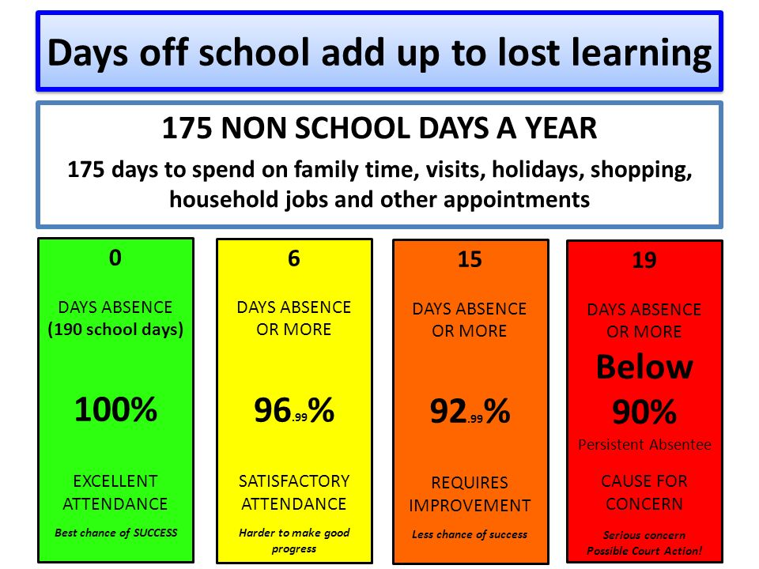At Clowne Infant and Nursery School, we know from experience what a positive impact regular attendance has on not only children’s education, but also their well-being. It is clear to us how high rates of absence negatively affect children’s academic, social and emotional development. Teachers find that absence is disruptive for children and it can be almost impossible to catch up on any missed Learning. We want all of our pupils to have the very best possible opportunities to make the most of their education and to be happy and settled at school.

**Zero Tolerance**

Unfortunately, our attendance has been raised at our last two Ofsted inspections. It has been highlighted that we will now have to do everything we can to raise the attendance of our pupils to as close to 100% as possible, with 96% being considered “Satisfactory” whilst acknowledging that even at this level there will be an impact upon the pupil’s education. This has forced us into adopting a “zero tolerance” policy.

As part of this, we will review attendance weekly, and work alongside our Family Support Worker, Mrs Cross to raise attendance across school.

**What we will do if absence is becoming a problem for your child:**

* Send a letter to both parents/carers (where applicable) to let you know about the issue, including your child’s current attendance percentage
* Possible contact from our Family Support Worker to discuss any underlying issues.

**If poor attendance continues:**

* We will send a second letter followed up by an attendance panel meeting with the Headteacher and Family Support Worker in attendance alongside parents/carers.
* Should poor attendance continue, we will be forced to refer the case to the Local Authority to investigate further, issue fines, and potentially prosecute.

We do however, hope that we can avoid the above steps by working together. Please be aware that school have a legal requirement to follow up attendance issues. We aim to offer as much support as we can before the situation escalates.

We know that a range of circumstances including genuine illness causes absence from school. If your child is very unwell, of course they should not be in school. If you are struggling with attendance, please get in touch with us – we want to help.

The following are NOT acceptable reasons for absence:

* Tiredness
* A slight cold or other ailment which leaves the child “under the weather”, but able to cope with school
* Holidays or long weekends away
* Medical or dental appointments which could be made after school, or in the school holidays.

**Lateness**

If your child arrives late to school everyday, we **guarantee** that their learning will suffer. The graph below shows the serious impact “*just five minutes*” has:

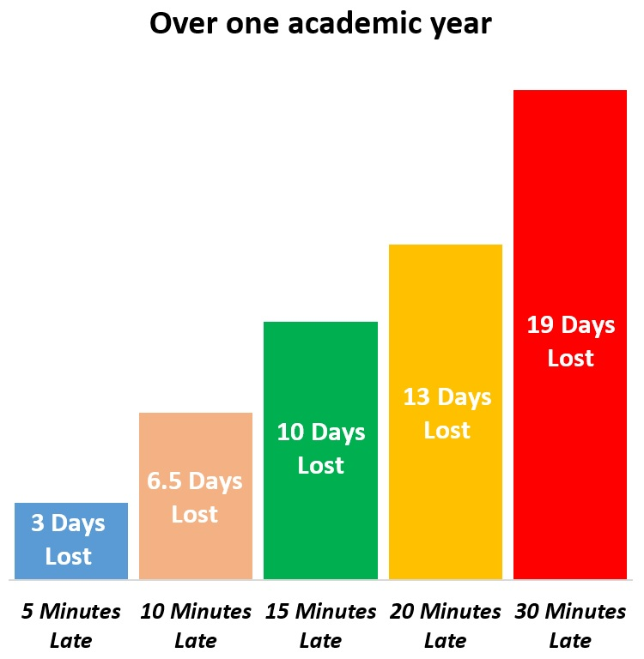

We will also be forced to make Local Authority referrals for poor punctuality at school, alongside persistent absence.

In addition to missing 10 full school days a year if your child is 15 minutes late, this will also mean that they will never access phonics lessons, which are taught first thing in a morning, which in turn puts them at a huge disadvantage before they attempt to access any other elements of the curriculum.

Equally as important, some children feel very embarrassed and self-conscious walking into a lesson that has already started, which is not the start to the day we want for any pupil.